Step 1: Review and Create

Step 1 : Review and Create

Step 2: Deployment Succeeded

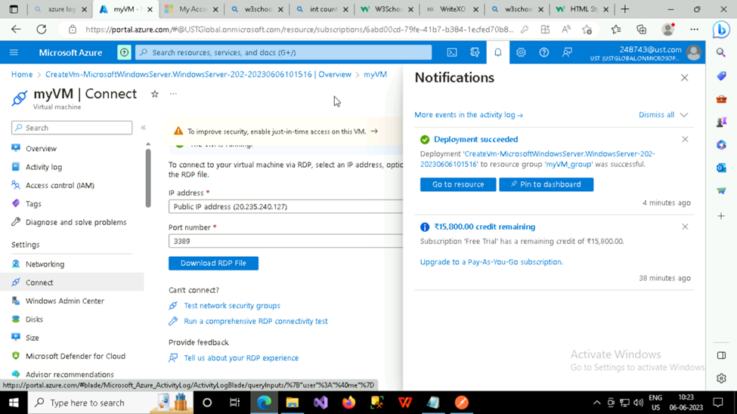

Step 3: Connect

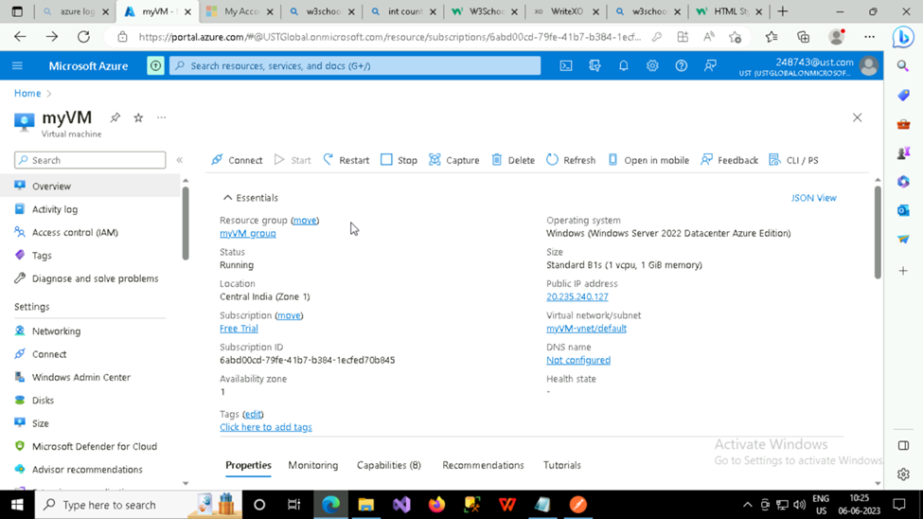

Step 4: Download RDP File

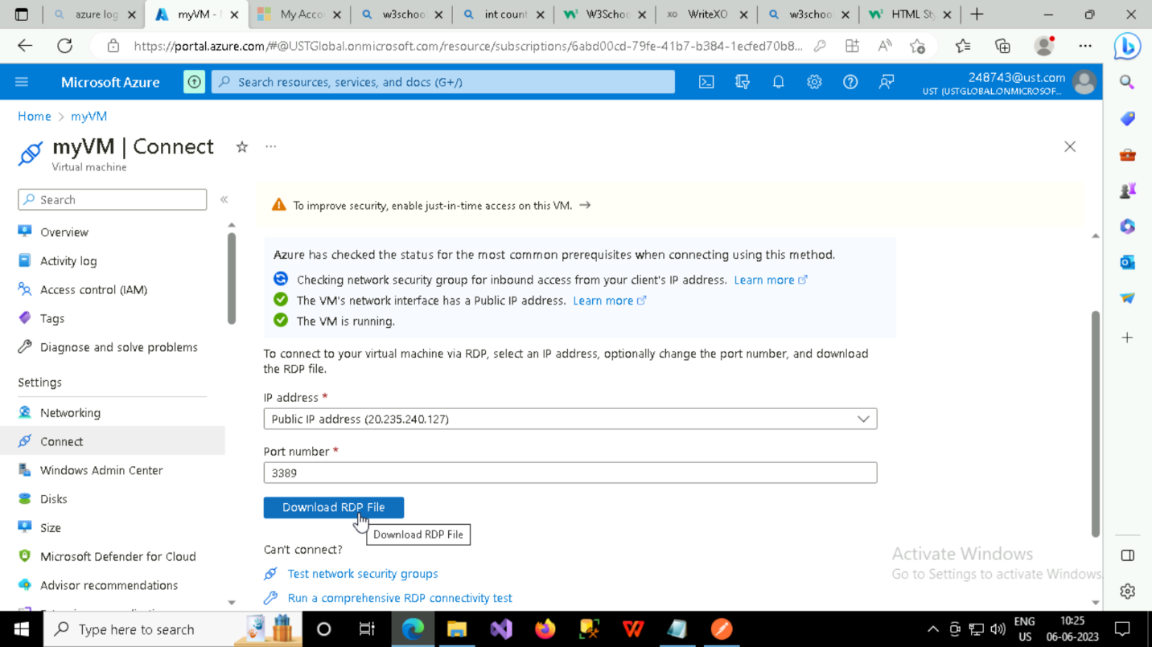

Step 5: Creation of Virtual Machine

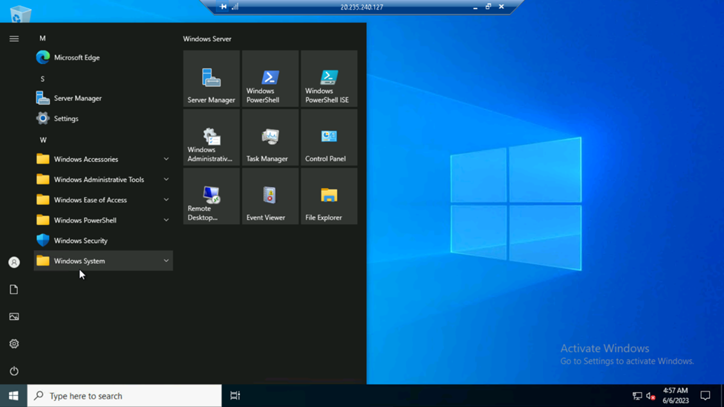

Step 6 : Record display

Step 7: Deleting Resource Group

